
TOBB ETU
Economy & Technology University
BIL 495 / YAP 495
System Architecture Document (SAD)
Reference: IEEE 42010 / INCOSE SE Handbook 5th Ed.

Document Control Table
Document Title | Project Closure Report
Document ID | (To be assigned)
Prepared By (Author) | FinalStack
Reviewed By
Approved By
Preparation Date | 11.11.2025
Approval Date | 11.11.2025
Version / Revision | 1.0
Confidentiality Level | Restricted
Reference Standards | IEEE 15288, IEEE 12207, INCOSE SE Handbook v5

Change Record (Revision History Table)
Revision | Date | Prepared By | Reviewed/Approved By | Description of Change
1.0 | 11.11.2025 | FinalStack | FinalStack | Initial Release

1. Introduction
2. System Context
3. Architectural Views
3.1 Logical View
3.2 Process View
3.3 Physical View
3.4 Development View
4. Design Decisions
5. Compliance and Standards
6. Appendix
7. References

1. Introduction
The architecture defines a secure, interoperable system that unifies all NICU data sources under standardized protocols such as HL7, DICOM, and FHIR.
It enables real-time data ingestion, AI-driven preprocessing, and clinical visualization to improve decision-making and patient outcomes in NICUs.
The architecture covers:
- Real-time acquisition and integration of NICU physiological, imaging, and clinical data
- AI-enhanced preprocessing pipeline for data cleaning, normalization, and standardization (HL7, DICOM, FHIR)
- Secure data storage and web-based visualization

2. System Context
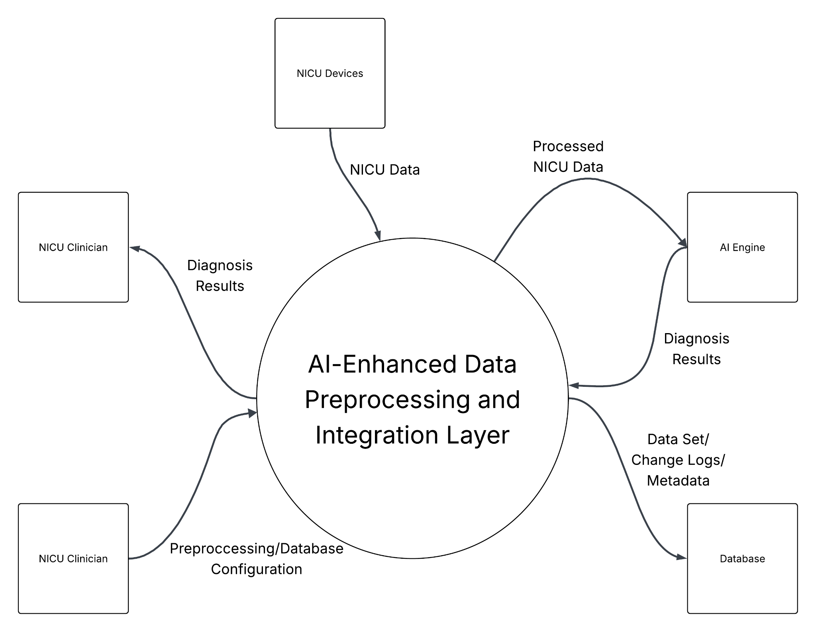

3. Architectural Views

3.1 Logical View
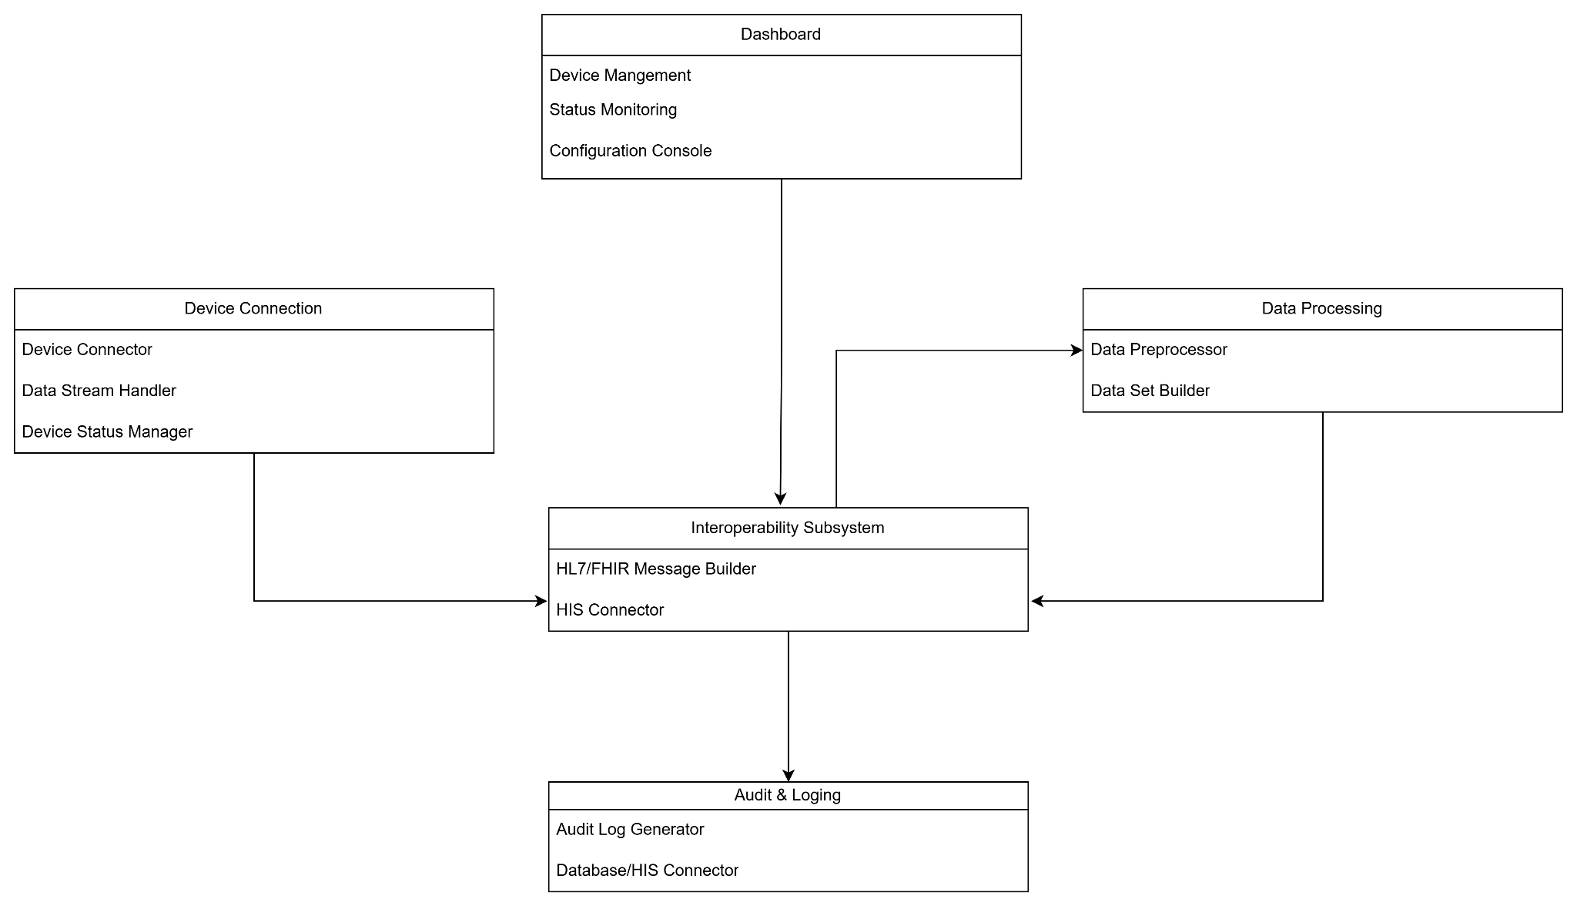

3.2 Process View
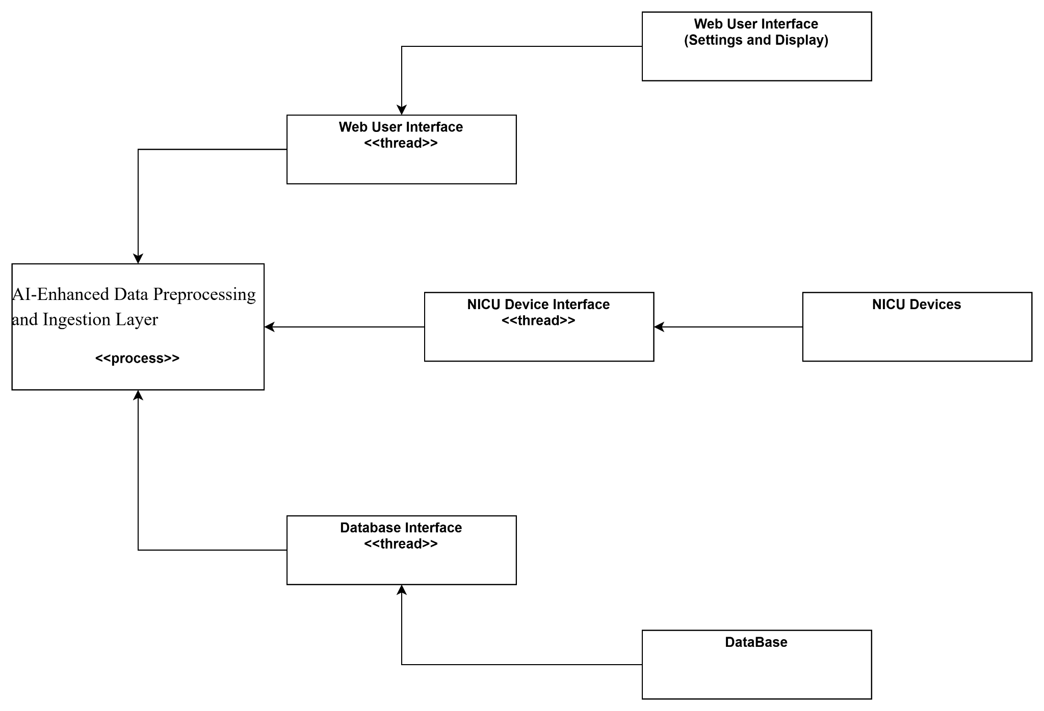

3.3 Physical View
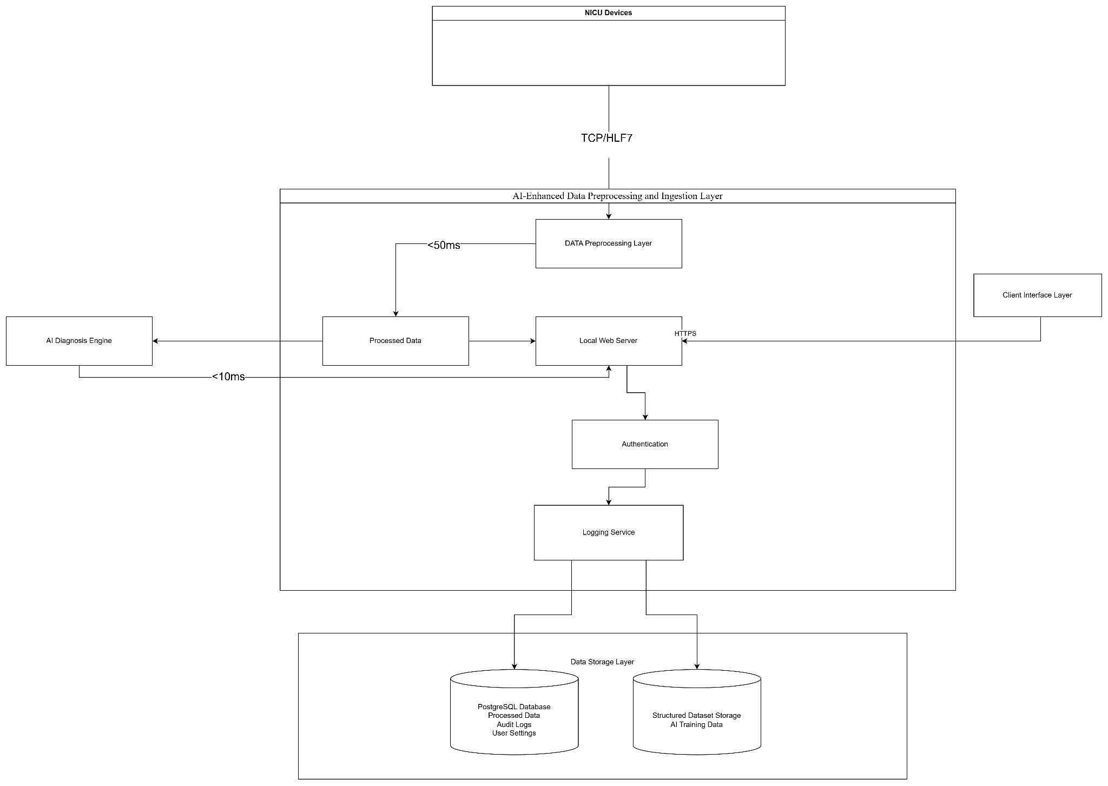

3.4 Development View
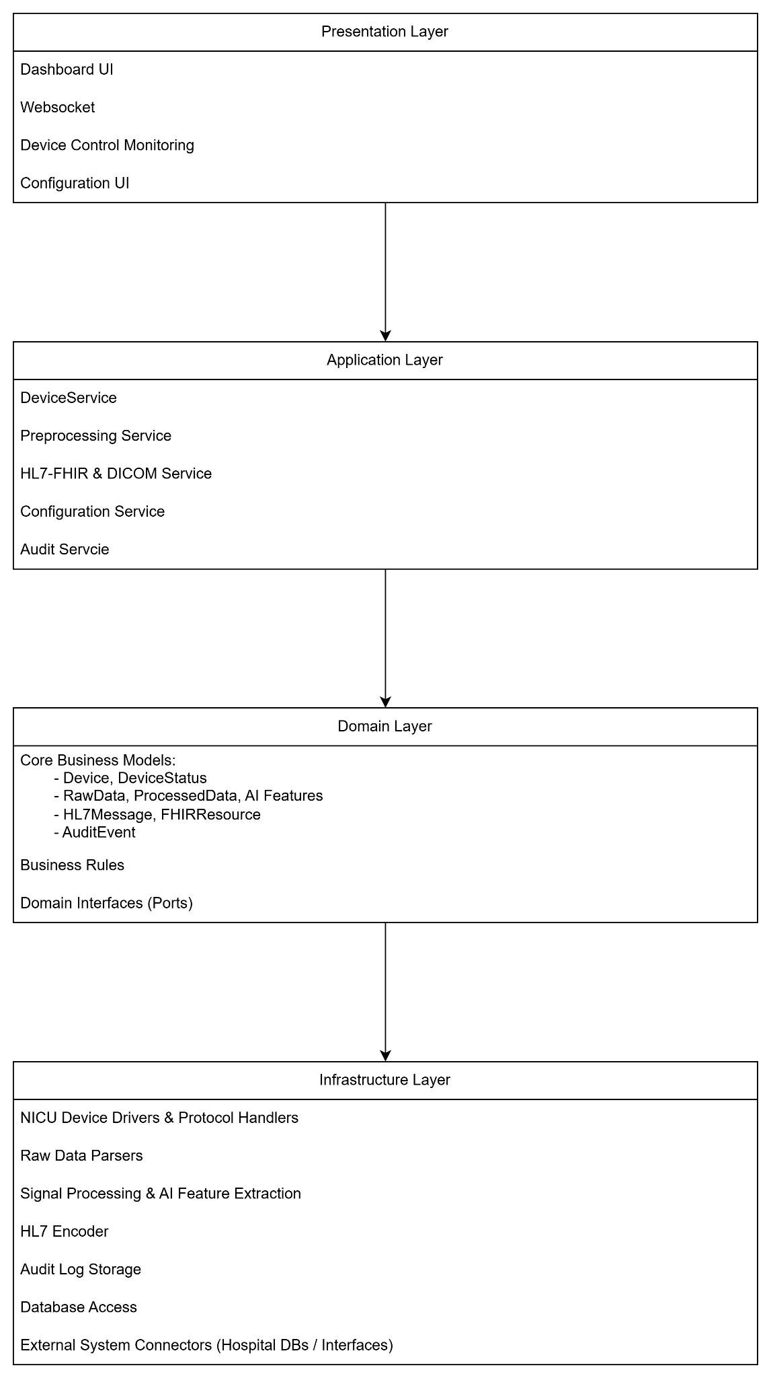

4. Design Decisions
Layered Architecture was chosen because it enhances modularity, readability, and maintainability of the system. By clearly separating the responsibilities of each component, it allows easier debugging, testing, and future scalability without affecting other layers.
Event-Driven Architecture was selected to support real-time data processing with low latency and high performance. It enables asynchronous communication and loose coupling between components, which makes the system more responsive, resilient, and easier to extend as new event sources or services are added.

5. Compliance and Standards

Standard / Regulation | Description / Purpose | Applicability
GDPR (EU 2016/679) | General Data Protection Regulation. Ensures lawful, fair, and transparent processing of personal data in the EU. | Mandatory for all patient data handling, anonymization, consent management, and storage.
ISO/IEC 27001 | Information Security Management Systems (ISMS). | Used to guide secure data storage, access control, and risk management.
ISO/IEC 27018 | Code of practice for protection of personally identifiable information (PII) in public clouds. | Ensures cloud-based storage or processing components meet privacy protection standards.
HL7 (Health Level Seven) | International standard for transfer of clinical and administrative data between software applications. | Used for all clinical data communication and structuring of NICU sensor data.
DICOM (Digital Imaging and Communications in Medicine) | International standard for handling, storing, printing, and transmitting medical imaging information. | Applied to ensure interoperability for image data acquisition and processing.
FHIR (Fast Healthcare Interoperability Resources) | Modern HL7-based standard for healthcare data exchange. | Will be used to enhance interoperability with hospital information systems and AI diagnosis modules.

6. Appendix

7. References
- GDPR (EU 2016/679)
- HL7 (Health Level Seven)
- DICOM (Digital Imaging and Communications in Medicine)
- FHIR (Fast Healthcare Interoperability Resources)

